|  |  |
| --- | --- |
| Soaring Tigers Fleet of Sailplanes  Van Sant Airport in Erwinna, PA | soaringtigers_1000 |

For more information about club membership please contact us at [mbs@iaa.com](mailto:mbs@iaa.com) and 609-924-6939

# Schweizer SGS 1-26B Single Place Sailplane

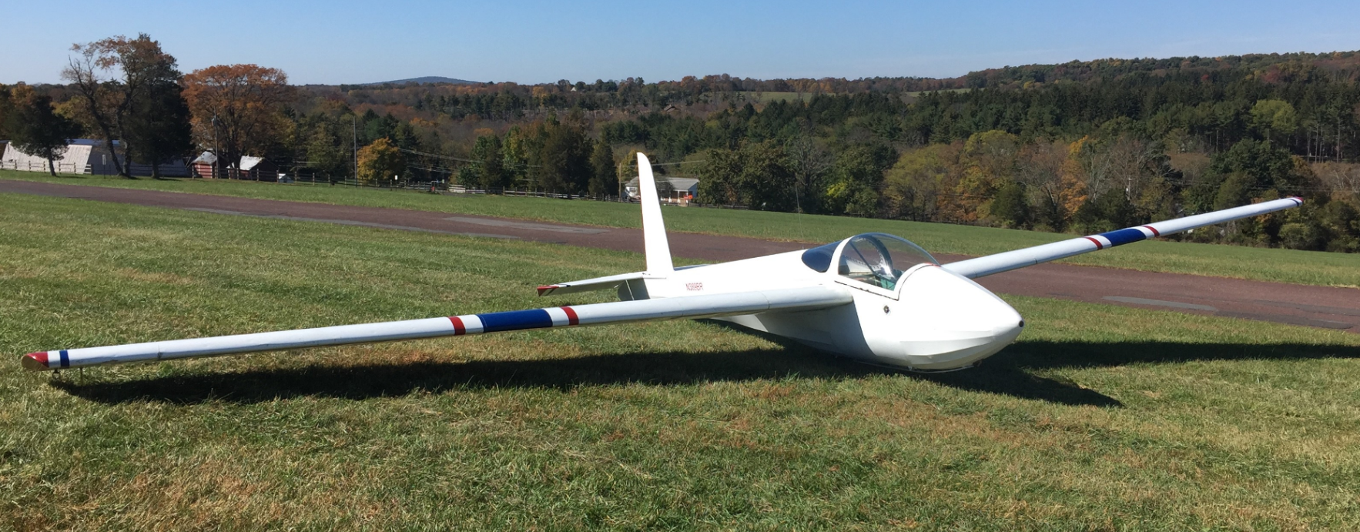

# Schweizer SGS 1-34 Single Place Sailplane and our Gliderport’s Piper Pawnee Tow Plane

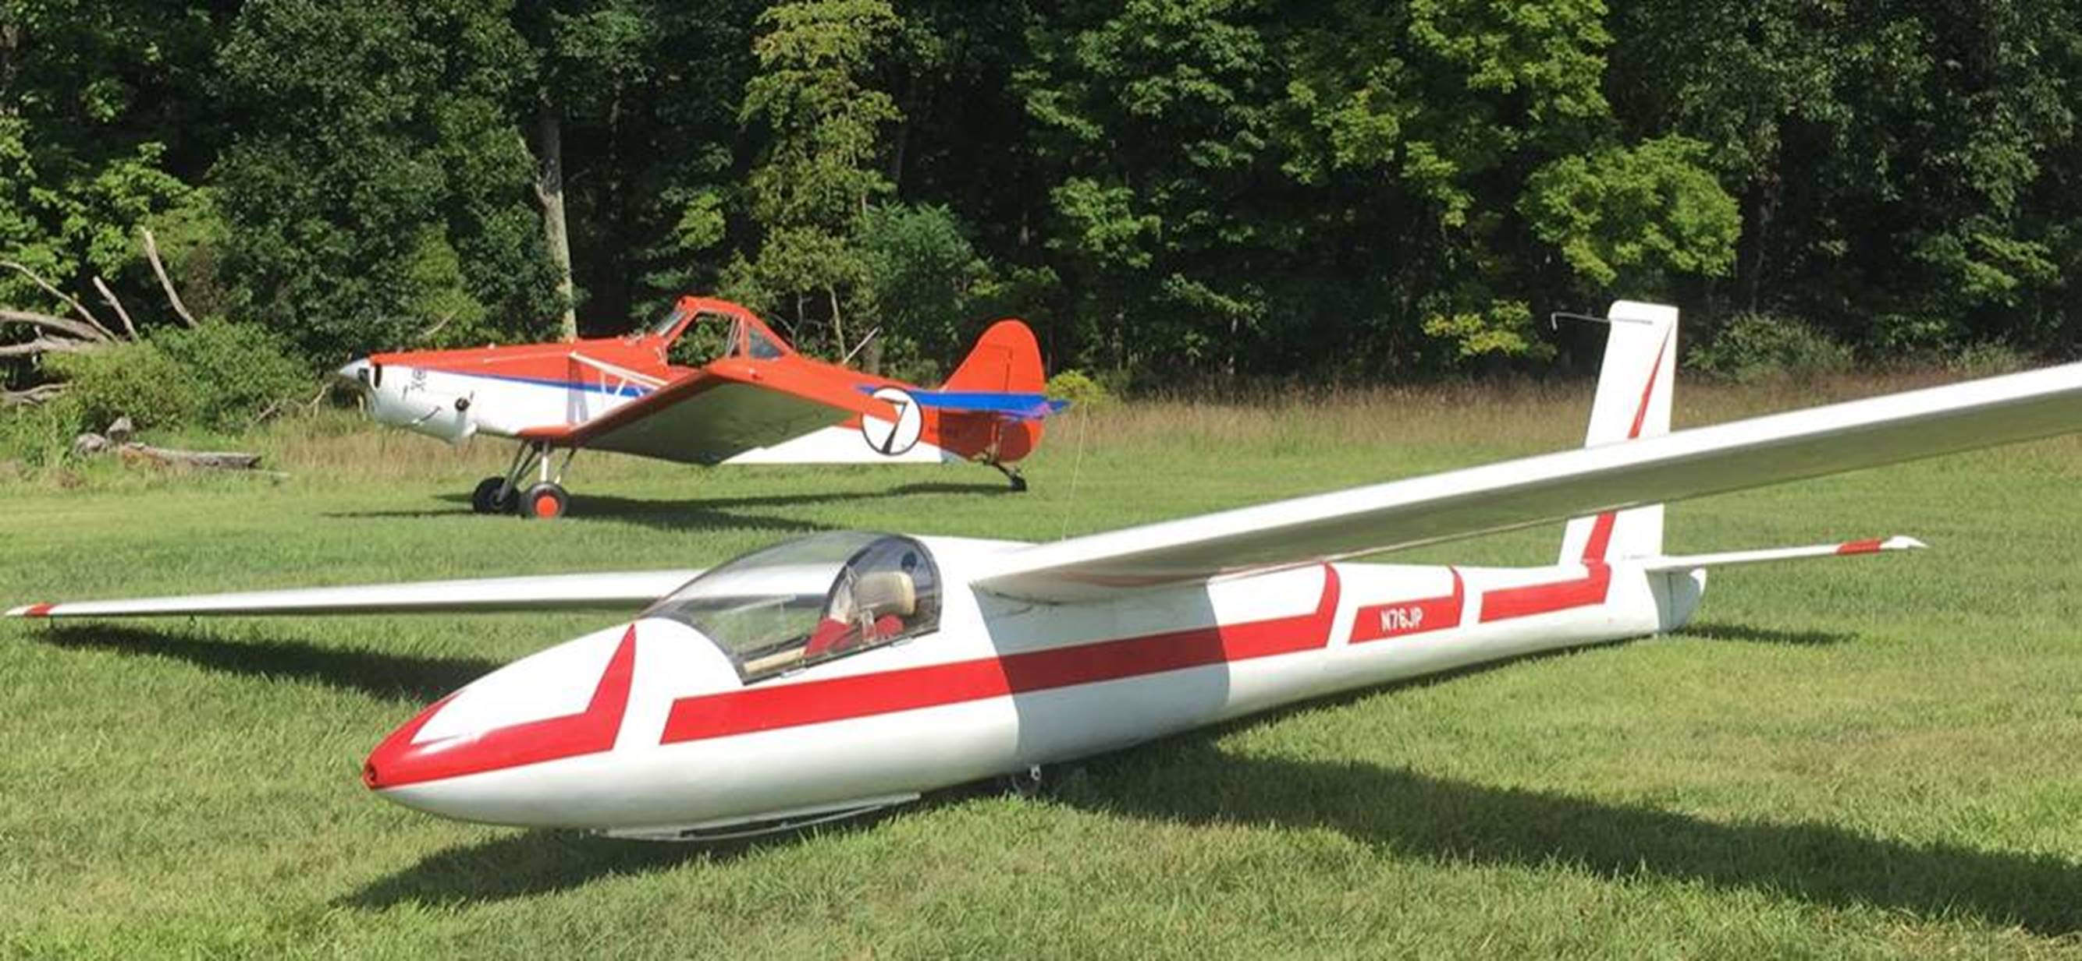

# Schweizer SGS 1-34 Single Place Sailplane Instrument Panel

# Schweizer SGS 2-33A Dual Place Sailplane for Flight Training, Solo, Flight Reviews, FAA Flight Tests, and Passenger Rides

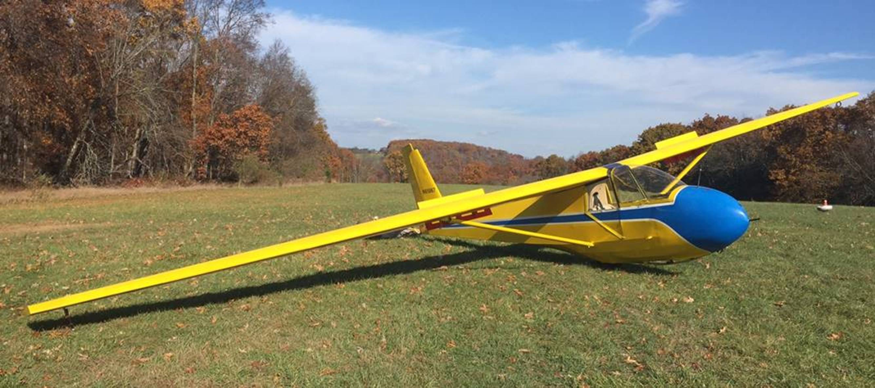

# Schweizer SGS 2-33A Instrument Panel

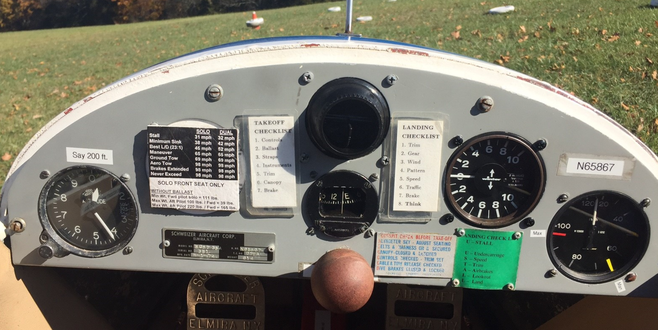

# Front and Rear Seating of the Schweizer SGS 2-33A

